**Computer Graphics and Concepts**

**Carson Foster**

This lesson will cover the basic concepts behind 2D computer graphics. In addition, we’ll look at 2D transformations as well.

Introduction

Essentially, there are two important types of 2D graphics: raster and vector. Essentially, raster graphics deal with pixels, which are essentially small squares that can become different colors, and vector graphics deal with mathematical equations and relationships. We won’t discuss vector graphics much, as we’re mainly concerned with raster graphics. Your monitor uses a raster graphics system, with many pixels on the screen, with each pixel essentially holding a color.

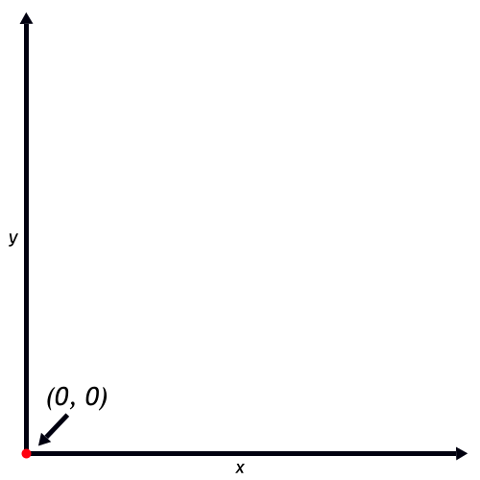In computer graphics, the most common color model is RGB or RGBA (for red, green, and blue, and sometimes alpha). In the RGB model, every color is described by three numbers, representing the amounts of red, green, and blue light in each color. For RGBA, there is an additional number, which is called the alpha. This alpha value describes the opacity of the color, with low values meaning a color is easy to see through. Each of these numbers is between 0 and 255, inclusive. Therefore, a color value of (255, 0, 0, 255) in the RGBA model means a 100% opaque, 100% red color. Likewise, (140, 0, 120, 255) in the RGBA model means a 100% opaque, reddish-purple color.

In addition to color, each pixel has a location on the screen, in the form of coordinates. Remember the Cartesian coordinate system from math class? It’s pictured to the right, in case you forgot. In this classic system, the positive directions for x and y are to the right and up, respectively. When we only look at positive x’s and y’s, we consider ourselves to be looking at Quadrant I. In the familiar coordinate system, the origin is at the bottom left of Quadrant I.

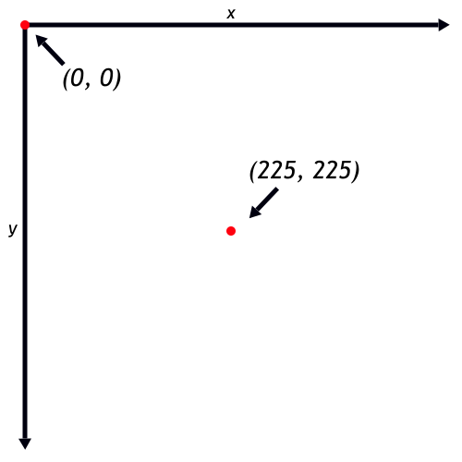However, this is not how computers view their pixels. Instead, computer graphics commonly use a different, but similar, Cartesian coordinate system. In this modified system, the positive directions for x and y are to the right and down, respectively. What this means is that in Quadrant I, the origin is now at the top left. In this system, as x increases, it moves farther to the right, like in the normal system. However, as y increases, it moves farther down. This can take some getting used to, so bear this in mind while working with graphics.

Common Representations

For the purpose of graphics, there are some common conventions and representations it will be handy to remember. The most basic useful shape is the line, which is usually specified by 4 arguments: the starting x-value, the starting y-value, the ending x-value, and the ending y-value. These 4 arguments completely describe a line in 2D space. In addition, the most common representation of a rectangle is as follows: